**Convert images into csv file**

We want to convert images into excel file by using Notepad++. Step by step guides are explain given below.

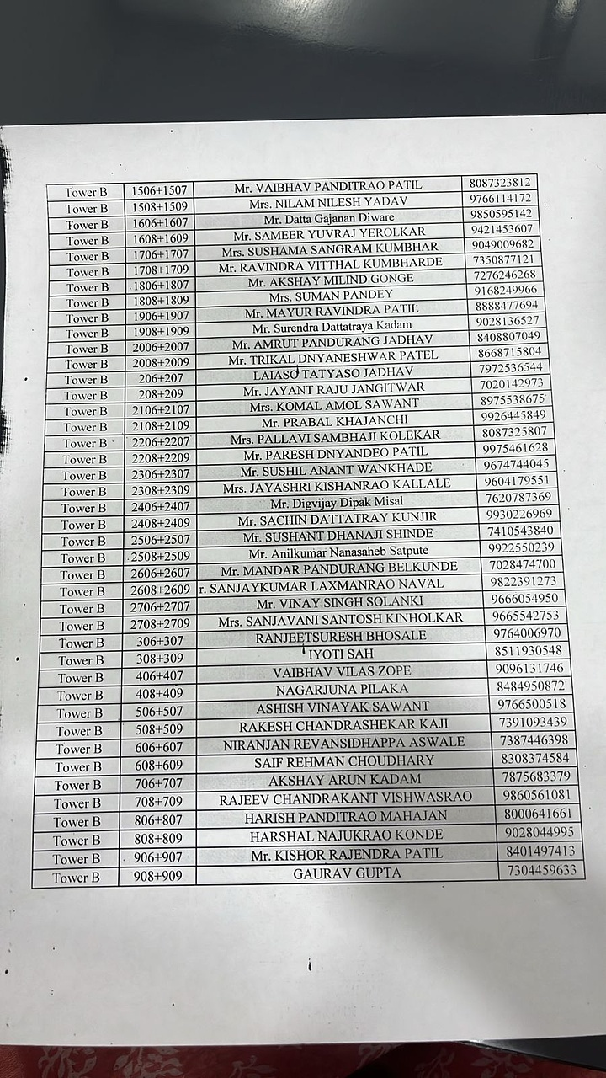

**Step 1: Open image in photo, then click Visual search with bing**

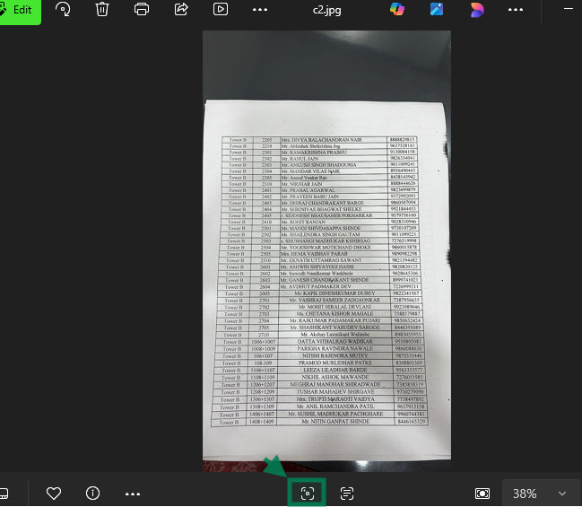

**Its redirected into any Browser. Click on Text.**

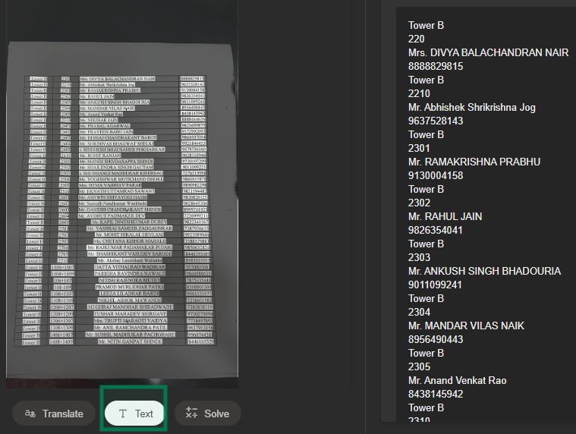

**Its generated text. Copy and pasted into notepad++.**

**Step 2: Open the text in Notepad++**

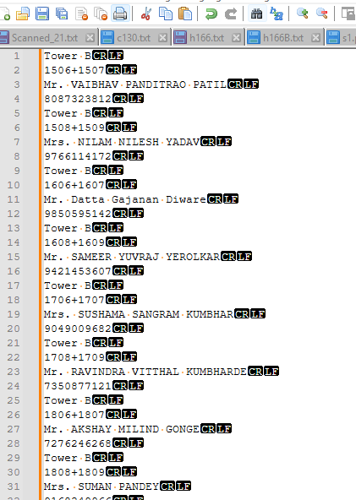

**Step 3: Open Find & Replace**

1. **Press Ctrl + H.**
2. **Check Match using Regular Expression**

**Step 4: Replace line breaks to prepare for CSV**

**Since each record has 4 lines (Tower name, Unit number, Name, Contact), we want each record in a single line:**

1. **Find what: (\r?\n)**
2. **Replace with: (,)**
3. **Click Replace All.**

This will create a long single line like:

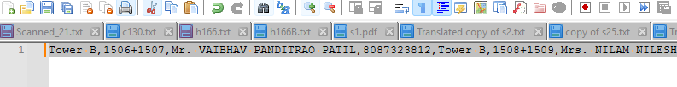

**Step 5: Split each record into a new line**

1. **Find what: (Tower [A-Z]),([^,]+),([^,]+),(\d+),**
2. **Replace with: (\1,\2,\3,\4\n)**
3. Click **Replace All**.

Now your text should look like:

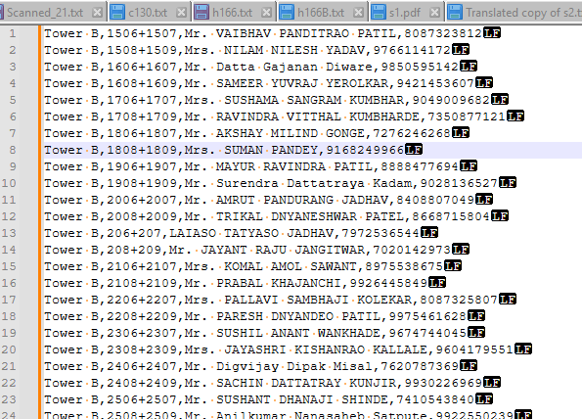

**Step 6: Save as CSV**

1. Go to **File → Save As**.
2. Change **Save as type** to **All Files**.
3. Name it Contact.csv.

We successfully converted from images into excel file.